**SPRINT 1 – JAVA**

By: Elliott Butt, Joseph Flores, Zachary Hulan

Date Submitted: June 26, 2024

**USER DOCUMENTATION**

INTRODUCTION

The Library Management System (LMS) is designed to simplify library operations. It handles everything from managing library items, authors, and patrons to borrowing and returning items. The menu system is user-friendly, making it easy for librarians to navigate and execute different tasks smoothly.

OVERVIEW

The five main features of LMS are:

1. Item Management:

* Add, edit, and delete library items.
* Supports different item types: Books (Printed, Electronic, Audio) and Periodicals (Printed, Electronic).

1. Author Management:

* Add, edit, and delete authors.
* Maintain a list of items authored by each author.

1. Patron Management:

* Add, edit, and delete patrons.
* Supports different patron types: Students and Employees.
* Maintain a list of items borrowed by each patron.

1. Library Item Borrowing:

* Search for items by title, author, or ISBN.
* Borrow available items and update the number of copies.

1. Library Item Returning:

* Search for borrowed items and return them.
* Update the number of copies upon return.

DIFFERENT CLASSES IN LMS

**Library Management System**

This is the main class that initializes the application and presents the interactive menu. It captures user input and directs the user to the appropriate functionality within the Library class.

Through the main menu, you can access all library management functionalities such as searching for items, authors and patrons, as well as borrowing and returning items.

**Library Item**

The Library Item class defines common properties and methods for all library items. The class contains common attributes like ID, title, author, ISBN, publisher, and number of copies. Subclasses for different types of library items:

* Book: Represents books in the library, with further subclasses for printed books, electronic books, and audiobooks.
* Periodical: Represents periodicals in the library, with subclasses for printed and electronic periodicals.

These classes are managed by the Library class. To add a new item, you will use the interactive menu to navigate to the option for adding library items, and the system will prompt you to enter details for the specific type of item. Similarly, users can edit or delete existing items by navigating to the respective options in the menu.

**Author**

The Author class represents authors in the library system. Each author has a name, date of birth, and a list of items they have written. The class provides methods to add, edit, and delete author information.

The Author class instances are managed by the Library class. Through the interactive menu, you can add, edit, or delete authors. The system will prompt you to enter details such as the author's name, date of birth, and items they have written.

**Patron**

Patrons will include this information: address, phone number, and a list of borrowed items. There are two specific types of patrons:

* Student: Represents student patrons.
* Employee: Represents employee patrons.

**Library**

The Library class is responsible for the overall management of items, authors, and patrons. It provides methods to search for items by title, author, or ISBN, and to handle the borrowing and returning of items. The class ensures that items are available for borrowing and updates the system when items are returned. This functionality is accessible through the main menu.

When borrowing and returning items, users can execute these actions through the respective menu options. The Library class interacts with patron information to track which items are borrowed by each patron. Borrowed items are added to the borrowing patron's record, and the system updates the item's availability. When items are returned, the system reflects these changes, ensuring accurate tracking of all library resources.

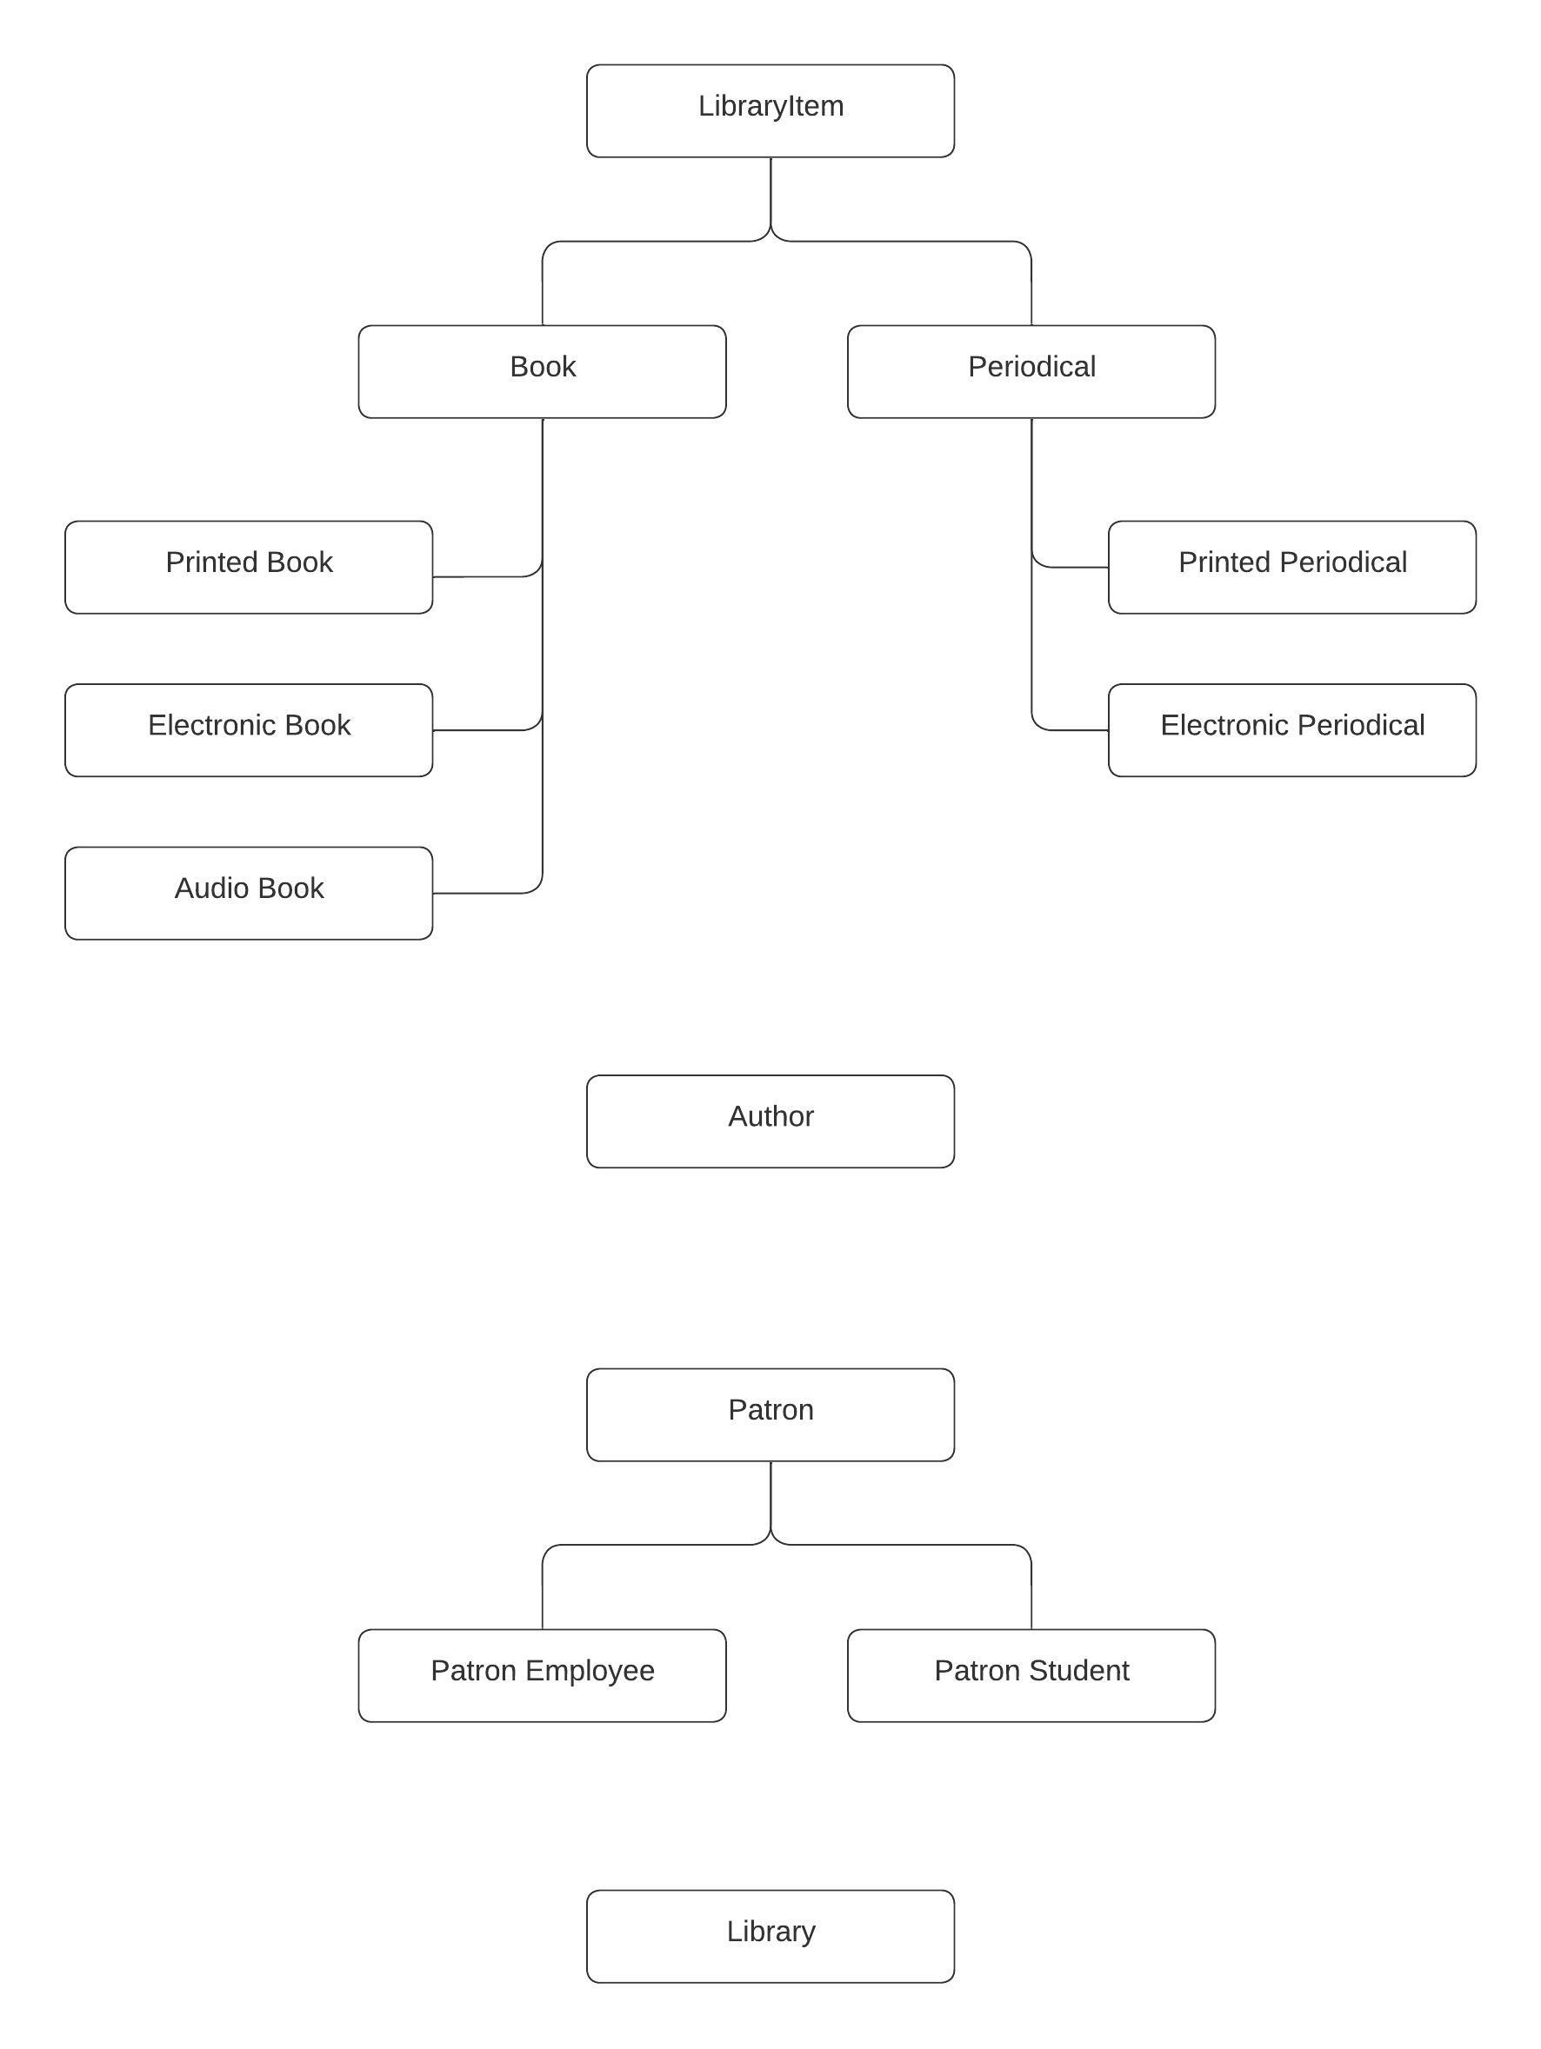

Figure 1. Class diagram of the Library Management System.

**DEVELOPMENT DOCUMENTATION**

DIRECTORY STRUCTURE

A description of the source code directory structure is provided below:

src/

Library.java

Menu.java

TestData.java

README.md

author-management/

Author.java

challenges/

Intellij Screenshot.png

item-management/

Book.java

BookAudio.java

BookElectronic.java

BookPrinted.java

LibraryItem.java

Periodical.java

PeriodicalElectronic.java

PeriodicalPrinted.java

patron-management/

Patron.java

PatronEmployee.java

PatronStudent.java

JAVADOCS

Additionally, the javadocs folder can be found under the Documentation folder.

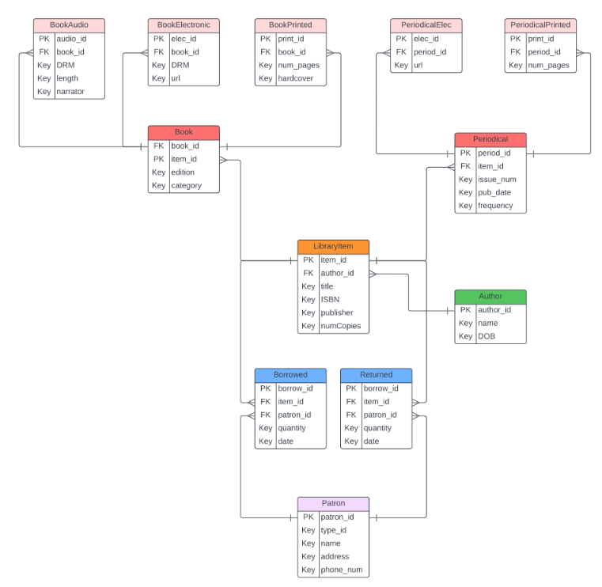

Figure 2. Entity Relationship Design for the database

**DEPLOYMENT DOCUMENTATION**

INSTALLATION MANUAL

1. Download all files off the GitHub Repository

Go to <https://github.com/nest-dev-team/sprint-1-spring-2024-java>, create a folder anywhere on the device, and download all the files from the repository into that folder.

1. Open Menu.java in VSCode

Navigate into the folder and right click on Menu.java and press open with, then find and click on Visual Studio Code.

1. Start the program

On the top right of your screen you should see a play button, click that and a terminal will open on the bottom of the screen with the Library Management System running in it.